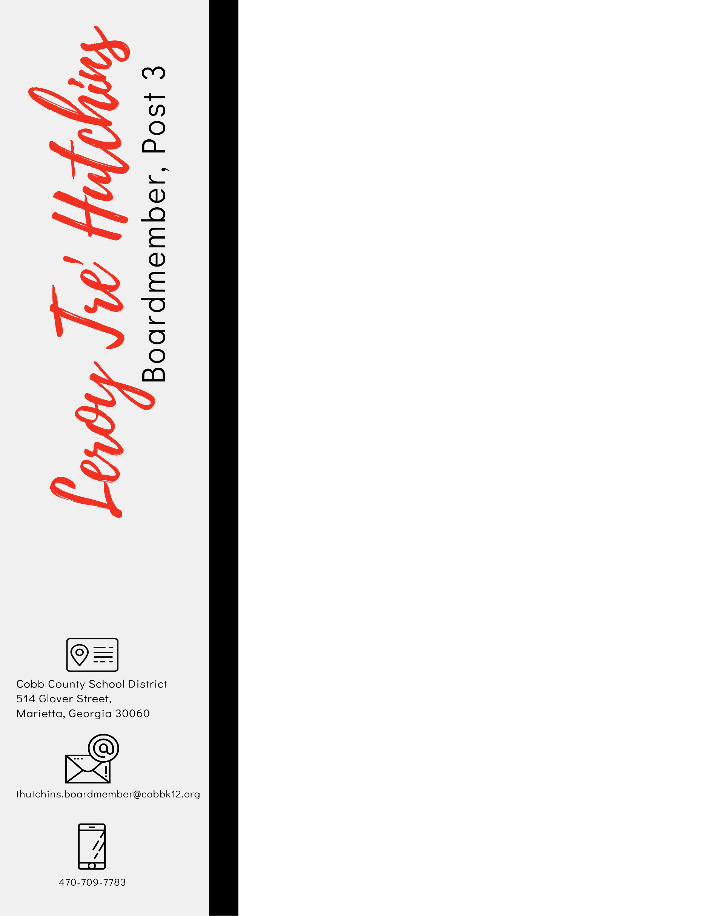

To The Scholarship Committee,

It is a great pleasure to refer Jorden Clay. Jorden is one of the most exceptional students I have encountered in the last 7 years. He is a leader amongst leaders and is active in the improvement of his community.
Jorden is also one of the most talented individuals I have encountered. Jorden’s oratorical skills are exceptional. He has lent his gift to our community on numerous occasions and it’s always a blessing. In addition, Jorden has served the community in many endeavors through the local PTA as well as local civic organizations.
During the last couple years, because of COVID 19, our community has banned together to ensure the most vulnerable have the necessary resources to thrive during these perilous times. As a result, we begin a Food Distribution at various locations throughout south Cobb County. From day one, Jorden has lent his time, efforts and energy to help meet the needs of our community. Through our interactions, Jorden has proven to not just be a leader but a public servant. I look forward to all the great things Jorden will do in the future.
Jorden has my highest referral. He has demonstrated excellence in all that he puts his mind to, which leads me to believe there will be no limit to his growth and achievements in college and beyond. Please don't hesitate to contact me at thutchins.boardmember@cobbk12.org if you have any questions.

Thank you for your time and consideration,

Tre’

 | Leroy Tre’ Hutchins (He/Him/His)  Board Member, Post 3  Mobile: 470-709-7783  Email: thutchins.boardmember@cobbk12.org  541 Glover Street  Marietta, Georgia 30060  www.cobbk12.org  “Education is about improving the lives of others and for leaving your community and world better than you found it.” – Marian Wright Edelman

