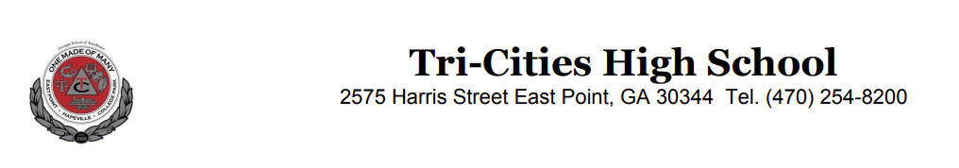
February 8, 2023

To Whom It May Concern,

I have had the privilege of knowing Christopher Lambry during the 2022-23 school year while he served as one of the ambassadors and student aids in our school’s wraparound center, The Unidos Center, at Tri-Cities High School.

Chris worked in the center with me throughout the year and has displayed many leadership qualities. He is dedicated, reliable, honest, hardworking, consistent, and polite. Chris is extremely helpful and always willing to volunteer.

Academically, Chris has excellent grades, he takes Honor classes, AP classes and completed one dual enrollment class at Morehouse College. In 9th and 10th grade he was President of the Urban Debate League at Emory University. One of Chris’ most prestigious leadership roles this year is that he was selected to serve on the State of Georgia School Superintendent Richard Wood’s Advisory Council. He is also a member of the Fulton County School District Superintendent Mike Looney’s Advisory Board.

Outside of school, Chris is currently interning with state representative Kim Schofield. Additionally, he serves as a senior leader in 100 Black Men of South Metro Atlanta.

Chris will be the first in his family to attend college. He is the oldest of four siblings and was raised by his grandmother. He aspires to attend law school and one day become a federal judge. He is a role model and leader in his home, school, and the community. I highly recommend Mr. Chris Lambry.

Most Sincerely,

Sara Blake Smith, LCSW
School Social Worker
Tri-Cities High School
2575 Harris Street
East Point, GA 30344
404-557-1146

