Mr. William C. Wade, Principal

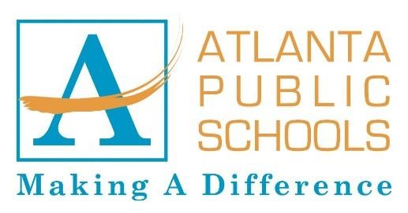
BOOKER T. WASHINGTON HIGH SCHOOL

45 WHITEHOUSE DRIVE SW

ATLANTA, GEORGIA 30314

(404) 802-4600

To: Whom it may concern:

It is with pleasure that I am given this opportunity to recommend Mr. Mahamad Drammeh for the ETA Omega Scholarship. Mr. Drammeh is a well-rounded individual. He excels academically which is why he is the Salutatorian for this 2023 graduating class of Booker T. Washinton High School with a 4.2 GPA. He is an awesome athlete, participating on the Bulldogs football and soccer teams. He is respectful and respected by the faculty, staff, and his peers. He was voted by his peers to represent them and the school as Mr. Washington High School 2022-23. I’ve known Mr. Drammeh for a year and a half. In the classroom he has demonstrated his intelligence in written and verbal form in his responses to the classroom tasks. He oftentimes assists other students in their difficulties of understanding.
Mr. Drammeh is dedicated to excellence. He excels in academics in all his core and elective courses. He is the standard for a young man on his journey to becoming great!
Finally, Mr. Drammeh always exhibits respect, integrity, loyalty to his beliefs and faith, and commitment to his academic endeavors. I am confident that Mr. Drammeh will make full use of this scholarship to continue thriving in his educational endeavors.

Educationally yours,
Jackie A. Robinson
Ms. Jackie A. Robinson
FBLA Advisor
Entrepreneurship Pathway
Accounting Pathway

